Đặng Hoàng Nguyên - SE171946

**Name a few sections that are included in a man page.**

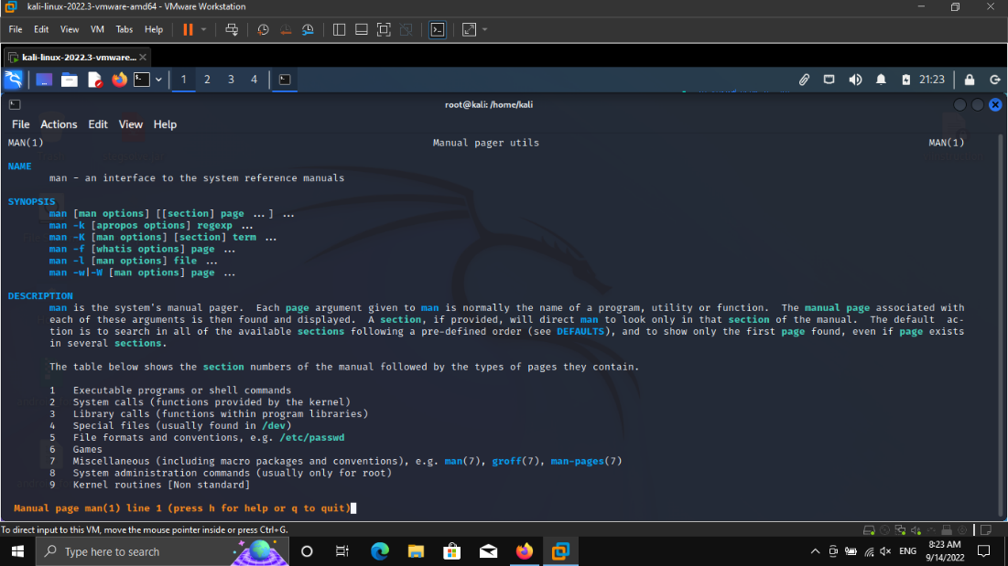

**What is the function of the cp command?**

cp - copy files and directories

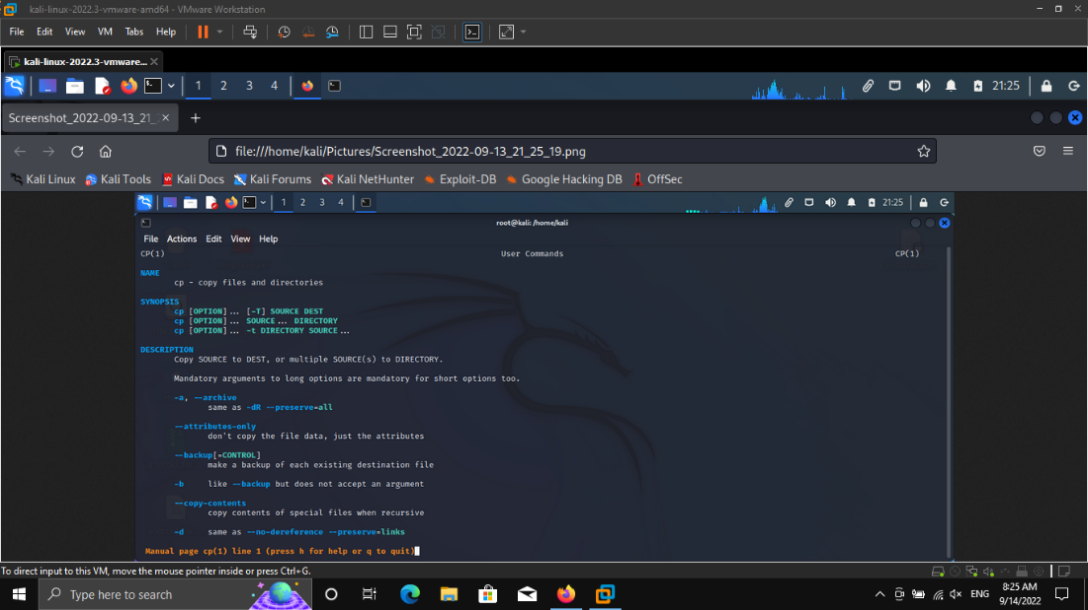

**What command would you use to find out more information about the pwd command? What is the function of the pwd command**

Use man to find out more information about the pwd command

pwd - print name of current/working directory

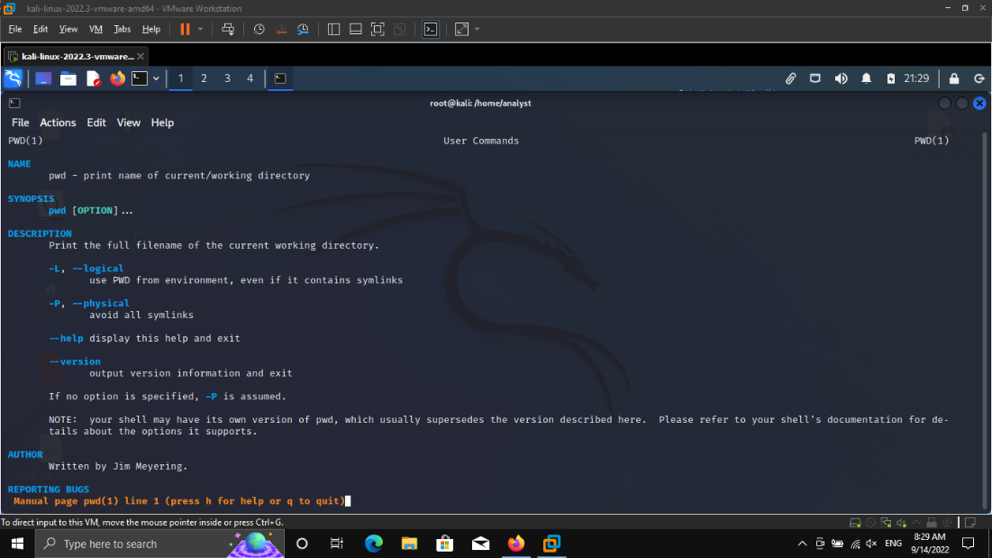

Create and change directories.

**What is the current directory?** /root

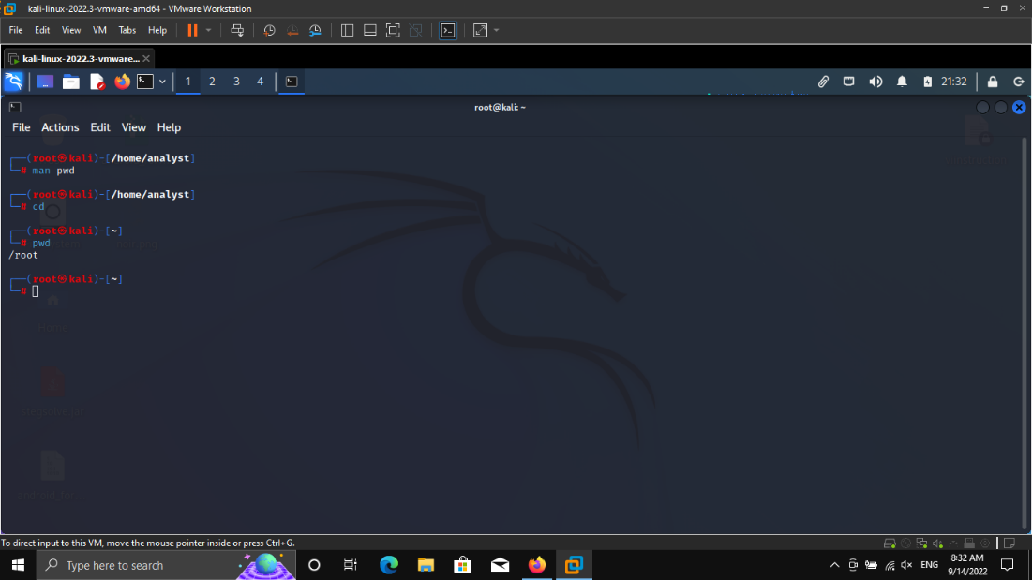

**Which folder are you in now?** cyops_folder3

**Type the command cd ~ and describe what happens. Why did this happen?**

The directory is changed to the home directory. Cd changes to the current user's home directory because the shell interprets the as a shortcut for that directory.

**Type cd . [analyst@secOps cyops_folder3]$ cd .**

**[analyst@secOps cyops_folder3]$ Question: What happens?**

**Nothing happen**

**Changing the directory to the .. directory, will change to the directory that is one level up. This directory is also known as parent directory. Type cd ..**

**[analyst@secOps cyops_folder3]$ cd ..**

**[analyst@secOps ~]$**

**Question: What happens?**

It directly go to analyst directory

**What would be the current directory if you issued the cd .. command at [analyst@secOps ~]$?**

It goes to home directory

**What would be the current directory if you issued the cd .. command at [analyst@secOps home]$?**

It turn to / directory

**What would be the current directory if you issued the cd .. command at [analyst@secOps /]$**

Nothing because it is in / directory now



Step 4: Redirect Outputs.

**Use the > operator to redirect the output of echo to a text file instead of to the screen:**

**analyst@secOps ~]$ echo This is a message echoed to the terminal by echo. > some_text_file.txt No output was shown. Question: Is that expected? Explain**

Because this echo command will save to a txt file called some_text_file.txt

**Once again, use the cat command to display the contents of the some_text_file.txt text file: [analyst@secOps ~]$ cat some_text_file.txt This is a DIFFERENT message, once again echoed to the terminal by echo. Question: What happened to the text file? Explain**

It replaces all the text in the file with the new one. Because when we are using > in the command echo, it will replace old text with the new one

**Step 5: Redirect and Append to a Text File.**

**Use the cat command to display the contents of the some_text_file.txt text file yet again: [analyst@secOps ~]$ cat some_text_file.txt This is a DIFFERENT message, once again echoed to the terminal by echo. This is another line of text. It will be APPENDED to the output file.**

**Question: What happened to the text file? Explain**

When using >> it will add in the new text unlike > it will remove all old text and then replace

**Step 6: Work with hidden files in Linux.**

**How many files are displayed?**

**How many files are displayed now, more than before? Explain.**

It displays more then before, It displays all the hidden file and normal file in the directory

**Is it possible to hide entire directories by adding a dot before its name as well? Are there any directories in the output of ls -la above?**

Yes, there are lots of them such as the picture below

**Give three examples of hidden files shown in the output of ls -la above.**

**What are the advantages of using the Linux command line?**

User can uses these command to control the system file, the CLI will use less resource when users administrate the computer remotely